MVC Step 1 (<https://docs.microsoft.com/en-us/aspnet/core/tutorials/first-mvc-app/start-mvc>)

## Create a web app

From the Visual Studio **Start** page, tap **New Project**.+

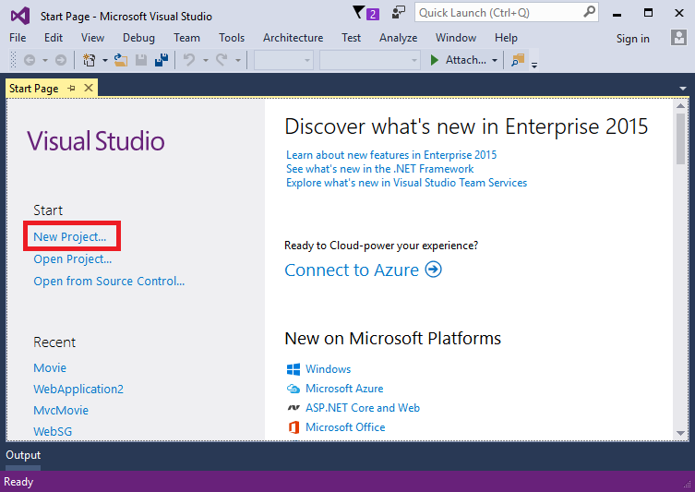+

Alternatively, you can use the menus to create a new project. Tap **File > New > Project**.+

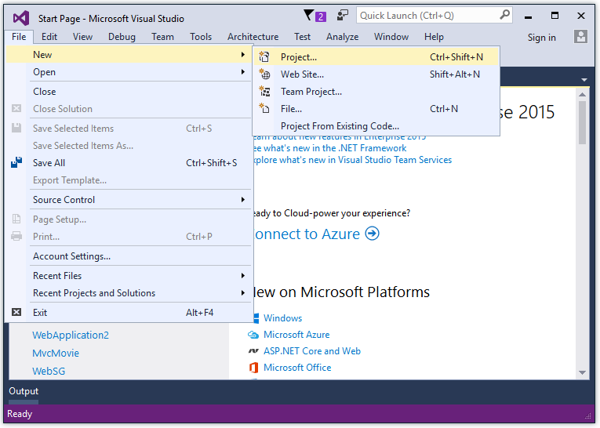

Complete the **New Project** dialog:+

* In the left pane, tap **.NET Core**
* In the center pane, tap **ASP.NET Core Web Application (.NET Core)**
* Name the project "MvcMovie" (It's important to name the project "MvcMovie" so when you copy code, the namespace will match.)
* Tap **OK**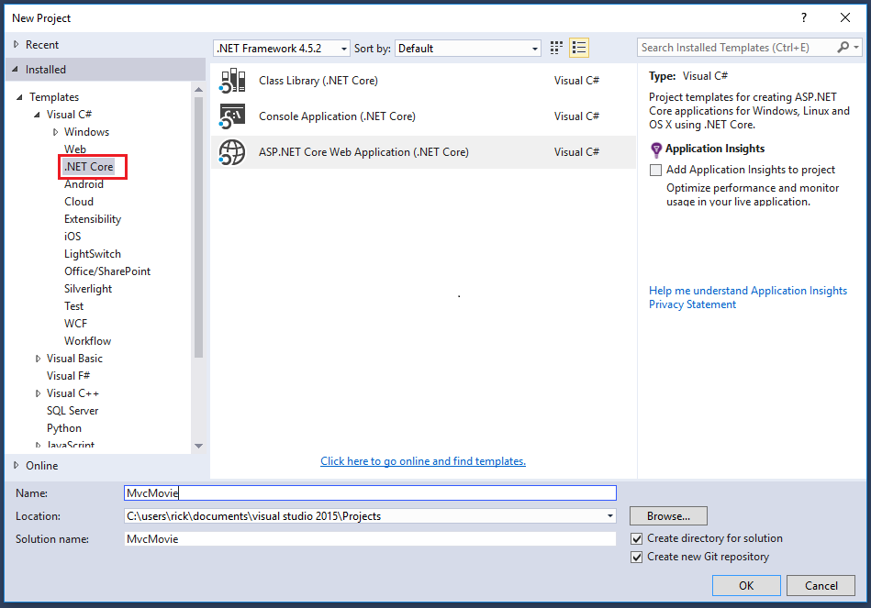+

Complete the **New ASP.NET Core Web Application - MvcMovie** dialog:

* Tap **Web Application**
* Clear **Host in the cloud**
* Tap **OK**.

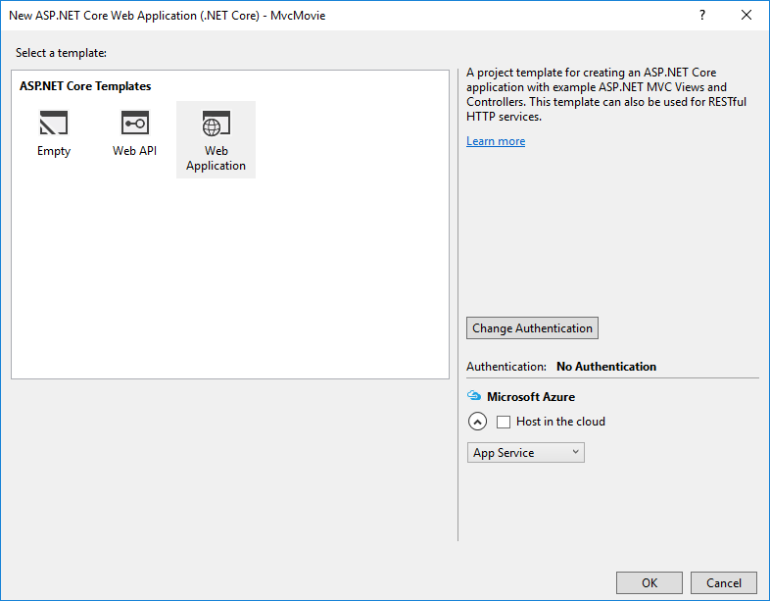+

##### Note

In Visual Studio 2017 RC, the **Host in the cloud** option is disabled and the dialog is slightly different than the illustration.

Visual Studio used a default template for the MVC project you just created, so you have a working app right now by entering a project name and selecting a few options. This is a simple "Hello World!" project, and it's a good place to start,

Tap **F5** to run the app in debug mode or **Ctrl-F5** in non-debug mode.

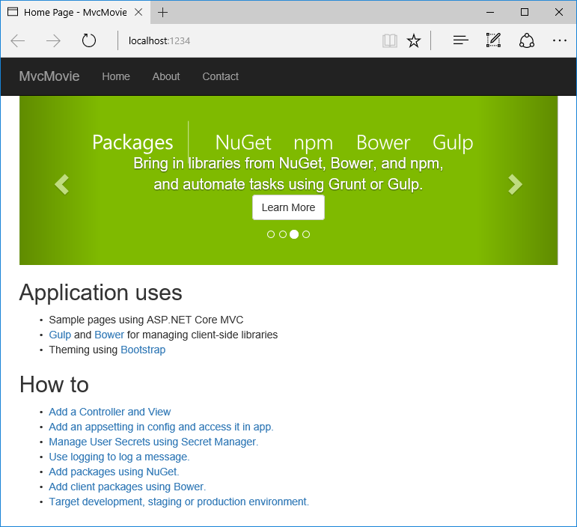+

* Visual Studio starts [IIS Express](http://www.iis.net/learn/extensions/introduction-to-iis-express/iis-express-overview) and runs your app. Notice that the address bar shows localhost:port# and not something like example.com. That's because localhost always points to your own local computer, which in this case is running the app you just created. When Visual Studio creates a web project, a random port is used for the web server. In the image above, the port number is 1234. When you run the app, you'll see a different port number.
* Launching the app with **Ctrl+F5** (non-debug mode) allows you to make code changes, save the file, refresh the browser, and see the code changes. Many developers prefer to use non-debug mode to quickly launch the app and view changes.
* You can launch the app in debug or non-debug mode from the **Debug** menu item:

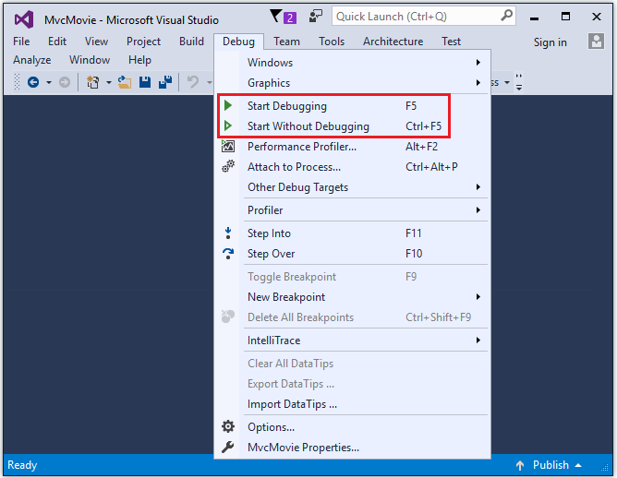+

* You can debug the app by tapping the **IIS Express** button

+

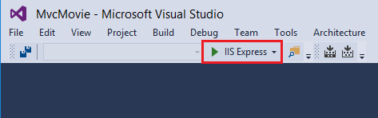+

The default template gives you working **Home, About** and **Contact** links. The browser image above doesn't show these links. Depending on the size of your browser, you might need to click the navigation icon to show them.

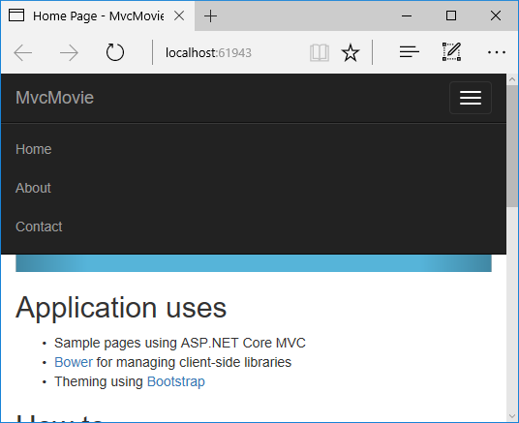3

If you were running in debug mode, tap **Shift-F5** to stop debugging.